Unit 6 Day 15

Today, we are going to review everything we have learned from the past week and a half.

How can we organize different activities we do when it is hot, cold, cool, and warm? We categorize them!

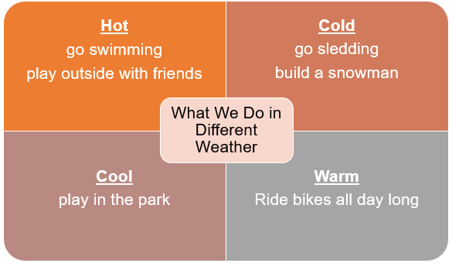

When we make an educated **guess**, this means that we are not sure about our answer, but we are going to make a **guess** no matter what.

We can use our guessing skills to make an inference.

To make an inference means you can look at a picture, words, and what you already know to make a guess about what is happening.

How to **Engage in Conversation**

|  |  |
| --- | --- |
| 1. I share my ideas. | I like to sled in the winter. |
| 1. I listen carefully to what the other person says. | I need to listen to my partner so that I know what to say next. |
| 1. I say something when the other person has finished. | No, I like hot weather. |

When someone is talking to you, you have to listen. It is the right thing to do. If you don’t listen, then you might miss some important information.

When you listen and make comments, it shows that you are engaged with the conversation.

When we ask questions, we use a question word. What are our 6 question words?

Who, Where, What, When, Why, and How

We do different things in different types of weather. We talk about what we want to do and what we have to do, too.

Activities! You are welcome to do all of these activities but please do at least three of them.

1. Have your child classify these activities into 2 groups (summer & winter):

Swimming Going to the beach

Sledding Having a picnic

Making a snowman

1. Have your child look out the window and make a guess about what kind of weather we will have today.
2. Have you child converse with someone and have a discussion about what they like to do in the spring time.
3. Have your child write 6 questions using the 6 questions words.
4. Have your child pick a type of weather and have them write 2 sentences about what they want to do and what they have to do during that type of weather.